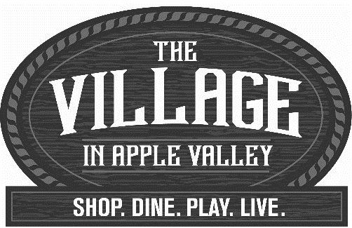
2024 Vendor Policies
(Detach and keep for your records, Specific Event Info is included - Updated 01/12/24)

The Town of Apple Valley is a Proud Sponsor of the events that are Hosted by The Village in Apple Valley. Although this is not a Town event all the regulations of the Town of Apple Valley apply to events that take place within the Township. By submitting a vendor application for an event located in The Town of Apple Valley you agree to abide by all special event requirements of the Town, Fire District, Apple Valley Village PBID and Board of Equalization Department provided on this form, event applications and other information provided by the Town or other agencies. You may be denied participation on the day of an event by representatives of the Town, Fire District and/or BOE Department for failure to comply with any of the stated conditions.
Vendors who fail to comply with any of the conditions herein.
are subject to removal from the area without a refund of vendor fees and may not be invited to participate in future events.

Vendor Acceptance Policies/Rules & Payment Schedule
- All Shade canopies must be secured in the event of high winds. You are required to have sufficient weights on each leg. If your canopy is not secured and weighted down, you will be required to remove it. NO exceptions will be made to this rule.
- No political campaigns will be accepted. Entries expressing political or social views are strictly prohibited and will be denied entry.
- No food or drink may be given away at this event.
- No vendor can conduct business outside of their designated area.
- No vendor can disrupt the business of another vendor.
- Vendors are required to stay until the event is scheduled to end. If you pack up early without prior approval from the event manager, your application will be denied for future events.
- Vendor acceptance is on a first-come first-served basis; and we limit the number of
- vendors selling the same item. Once you have turned in an application you will receive a copy
- that confirms your acceptance. We reserve the right to decline any application at our discretion.

- You will receive a confirmation via mail or email including event details no later than one week prior to the event. Let us know if we need to use regular mail to send you event details.

- Exclusivity and space location cannot be guaranteed.
- All payments must be received by August 31, 2024, to secure space reservation.

- Refunds are not issued for no- shows. No refund for cancellations within 10 days of an event unless the event is cancelled by the promoter. No refunds are given for claims of duplicated items, location, lost profits, etc. In the event of cancellation, notification will be made by 6:30 a.m. the morning of the parade/event via media (i.e., radio) and parade representatives. There will be no alternate event date. There will be no refunds only credits for vendor & parade entry fees. No refund will be given on sponsorship packages.
Board of Equalization Requirements

You are responsible for adhering to requirements of the Board of Equalization. A Resale License Permit is free to obtain. Below is a summary of these rules. For more details or questions, contact the BOE at (951) 680-6400 or www.boe.ca.gov website.
The same Resale Permit can be used for all events in the same location: but a new permit is needed for each new location.
- Your Resale Permit must reflect the physical address to where the event is taking place.
- Forms required from BOE:
- Marketing/Non-sales- No Permit needed
- Used items- 410-D form
- New items- Resale Permit
- Non-profit:
- New items: Resale Permit
- Used items: No Permit needed
- Non-Taxable food items- No permit unless event requires entry fee.
- Civic (School/Church)- No permit needed
- Mary Kay, Tupperware, Origami Owl, etc.- 410-D form
- Exempt Sale/Used items- Garage Sale/Flea Market type vendors are allowed
- (2) Non-Taxable garage sales per year
- The town may be fined $1000 for each vendor without the proper permits.
Submit a copy with the temporary address change with your application.
Event Requirements & Permits
Additional requirements and information are included on the various applications for each individual event.
FEES & PERMIT S

1. LATE FEES: All vendor spaces must be paid in full by August 31, 2024, to guarantee your space. A $40.00 NSF charge plus $25.00 processing fee for any returned checks. You will be denied future participation in Village in Apple Valley events if you do not settle the NSF fee(s) with the promoter. A 3% processing fee with be added to all credit card or “on-line” payments.

2. RESALE LICENSE PERMIT: By order of the State Board of Equalization, you must possess a free resale number permit if you are a non-food, new item vendor. The Town requires this permit be visible at all events. See event application for more details.

3. NON-PROFIT RATE: All vendors participating in Village Street Fairs are required to pay a vendor fee.

4. BUSINESS LICENSE: Vendors who operate a business in the Town of Apple Valley, or participate as a vendor in three or more Town events, must get a Town business license (see application). Each Sunset Concert date is considered a separate event.
5. FOOD VENDORS: All food vendors must have current health department permit to operate at temporary locations. Your booth or food trailer must meet all current health department requirements for food safety and sanitization. Current permit must be posted.

Merchandise and Booth Location

1. EXCLUSIVITY: No vendor is guaranteed exclusivity for an item although efforts are made not to duplicate certain items. All categories of items sold must be listed on your application, and the Event Coordinator must be notified of any changes to the list.

2. SPACE ASSIGNMENT: We will consider requests for a specific space; however, it cannot be guaranteed. Spaces are assigned to maximize traffic flow, avoid placing similar items together and meet vendor needs for access, electricity, fire and health department requirements and other factors.

3. SET UP/CLEAN UP: Vendor booths must be completely set-up and all vehicles removed from the event area at least 30 minutes before the event begins, or by the time stated on the event application. Vendors are required to remain set-up until the posted ending time of each event.

4. ACCEPTABLE ITEMS: All booths and merchandise must be maintained in good condition, in
good taste, and appropriate for family viewing. The Event Coordinator reserves the right to
order the removal of any items deemed inappropriate, disruptive, hazardous, or not listed on your application. For example, “Silly String”, “poppers” and “cap guns” are not allowed at any event.

5. MULTIPLE SPACES: Each vendor may operate only one of any one type of booth. For example, one vendor cannot rent two separate booths selling the same item at an event. If a vendor needs more than one space, they must be adjacent to each other.

SPECIAL REQUESTS: If you need special arrangement for load in or load outlet the event manager know before the event.
Booth Operation & Appearance
1. Vendors may not conduct business outside their booth space or by walking about the event.

2. Booths shall have professional looking signs. Handwritten signs are not permitted (Chalkboard type are allowed).

3. Vendors may not vary items sold from those listed on the application without prior notice and approval from the Event Coordinator.

4. Each booth must always have someone 18 years of age or older present. All workers must maintain appropriate attire and appearance.

5. All vendors must have an EZ-Up type canopy. That is secured and weighted down.

6. *All extra product and supplies stored in the booth shall be covered or screened from view.

A.V. Fire District Requirements

1. Fire Extinguishers: All vendors must have one easily accessible 2A10BC minimum rating fire extinguisher with a current service tag by a licensed California company.

2. All canopies: must be composed of flame-resistant material or treated with a flame retardant in an approved manner. All canopies must have a permanently affixed California Marshal label attesting to such.

3. No smoking: All vendors must have “No Smoking” signs posted in an obvious place.

4. Cooking tents: shall be separated from other tents and canopies by a minimum of 20 feet.

5. LP-Gas containers: shall be located outside tents and canopies, separated by a minimum of 5 feet.

6. Generators: and other internal combustion power sources shall be separated from tents and canopies by a minimum of 20 feet and isolated from contact with the public.
If you do not adhere to these requirements, you may not set up and no refund will be given.
For more details, please contact the AV Fire Protection District at (760) 247-7618.
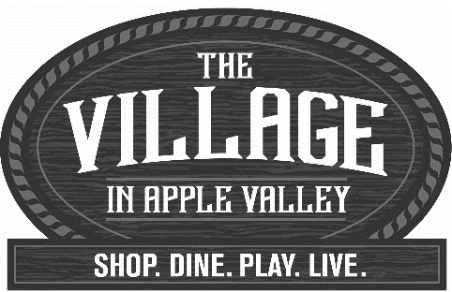
Event Information
2024 Happy Trails Parade &
Street Fair

Detailed Instructions and a location map will be sent out to you prior to the event. Below is general information about the 2024 Happy Trails Street Fair.
Event Date & Time: Saturday September 7, 2024 10:30AM-3PM
Street Fair Event Location: James A Woody Community Center
Street Fair Set up will be in the park and on Powhatan Road.

The Town of Apple Valley is a Proud Sponsor of the events that are Hosted by The Village in Apple Valley. Although this is not a Town event all the regulations of the Town of Apple Valley apply to events that take place within the Township.
- General Information:
Load In Instructions will be provided to you the week before the event.
- There is no electricity or water access
- A Town of Apple Valley Business License is required for vendors that have participated in three or more events held in the Town of Apple Valley. A photocopy must be provided with your application
- All applicants selling food must have health department permit/TFF permit – Submit copy with application.
- Payment is due by August 31, 2024
- Event set-up and space assignments are subject to change at any time and assigned by staff pending availability
- Set-up will be begin at 7:00AM; set up must be completed by 9:30AM (Call if you need special arrangements)
- DO NOT pack up prior 3:00PM and you must vacate by 4:30PM
- No Bake Sale, snack items or beverages may be sold, except by approved food vendors with a health department permit.
- NO food or drink can be given away at this event
- No supplies, tables or chairs will be provided
- Vendor parking will be available and determined the day of the event.
- All event vendors selling new, or food items must have a resale license. See attached Vendor Policies submit verification of BOE resale permit with temporary address listed. Address for Temp Sellers Permit: 13467 Navajo Rd, Apple Valley, CA 92308. Submit a copy with the temp address change with your application.

-All shade canopies must secure! Weights must be heavy enough to keep the canopy in place if the wind kicks up. You will be asked to remove your canopy if it is not properly secured.

